**The Columbia Club Foundation, Inc.**

**Foundation Meeting Tuesday February 18th, 2020**

**Board Room, 4th floor, Clubhouse 3:30pm**

**Call to order** **D. White**

**Approval of Minutes** **S. Helmerick**

**President’s Report** **D. White**

**Executive Director** **J. Rentchler**

**Policy & Procedures/By Laws C. Barker / G. Fuller**

**Nominating committee** **B. Killinger** **Arts & Artifacts** **C. Barker, S. Helmerick**

**History & Archives**

**Communications Committee** **S. Powell / C. Dorman**

**Legacy Committee/Insurance J. Brougher/ A. Jarmoszuk/G. Fuller**

**Grants S. Powell / A. Shankland**

**Events Committee C. Barker/C. Morgan /A. Jarm/S. Helmerick**

**Treasurer’s Report KD Del Fabro**

**Audit/Compliance/Endowment KD Del Fabro**

**Old Business Group**

**New Business Group**

**Announcements-Adjournment Group**

**Call in number 317-275-1178**

**Next meeting: March TBDh, 2020 at 3:30 pm in the Board Room**

**2020 Gala- Saturday April 25th**

**HAPPY VALENTINE’S DAY!**

**The Columbia Club Foundation, Inc.**

**Foundation Trustee Meeting January 21st 2020**

**The meeting was called to order by Darrell White**

**A Quorum** was established by the attendance of Darrell White, Brit Killinger, KD Del Fabro, Steve Powell, Clay Morgan, Shelley Helmerick, Andrew Jarmoszuk, Cris Dorman, Greg Fuller, Jim Rentchler, J. Lampkin, Jeff Brougher, and Al Hall.

**Excused Trustees:** Al Zimmerman, C Frost, B. Powers. The minutes were presented by S. Helmerick A motion was made by C. Barker to accept the minutes. The motion was seconded by S.Powell. The motion passed without dissension.

**President’s Report:** D. White wanted to discuss financial obligations to the club and the Gala. We have brought donations to the Legacy Fund and moving those funds to the Club. We sold two securities donated stocks to the Club so those monies could be changed over. These funds are for projects the Club owes monies for the Platinum Legacy Fund.

**Executive Director Report:** Mr. Rentchler discussed the update of the donors for the construction of the Platinum Society and up to date where we are looking for beginning of completion. We now have 110 donors and contributions of $1.8 Million in Pledges which is about $670,000 a year. We are ready to wrap up the 5th floor and the delay has been HVAC systems. We have had a few resign the club and have picked up new members which is also joining the Platinum Society. We will be open by March 1 ish. The bar is being built and furniture is in town. It will be quite a sight. We are starting the Wine Seller once the 5th floor is done. There will be a soft opening for the Platinum members some time at the first of March. We all came to an agreement with the transfer of funds at the Executive meeting today.

**Policies & Procedures and By Laws:** C. Barker has no comments.

**Nominating Committee:** Mr. B. Killinger commented that we have reached out to some candidates and are in the process of selecting potential new Trustees. We plan to have seats filled by the end of our fiscal year.

**Legacy Committee:** Nothing to report.

**Arts and Artifacts**: C. Barker we are having the art looked at and as soon as Jack Moriarty gets back from Florida we will be able to proceed with locating it.

**Communications Committee:** Mr. Dorman commented that the past two months we have been advertising the Gala and the next week an email will be going out to all members with links to download sponsorship opportunities. At the end of this month letters of acknowledgements will go out for donations for 2019.

**Legacy Committee/Insurance:**  G. Fuller has nothing to report.

**Grants:** Mr. Powell discussed the contracting of A. Shankland and that we are going to continue working with her on a month to month basis. S. Helmerick brought up that more specific information should be addressed like what is the hourly fee prior to hiring for specific projects. KD Del Fabro then discussed that we did receive the bill for December from Amy for $500.00. We decided that we need to keep things ongoing for a project basis and month to month. From January to April her time will be spent for sponsorships for the Gala. Mr. White questioned the affordability to the Foundation to cover her costs. We need her to raise more than what her charges are to us. She brought in $2,000 last year. He also discussed that we can’t lose money. D. White asked that we needed to all agree that she needs to be calling sponsors or ask for donations. We need to get people in the door to spend money. We are asking A. Shankland to go month to month and agree to change to 45 days from 15 days.

**Events Committee**: C. Barker updated Gala and she sold two sponsorships last night and the Gala is on J. Brougher’s birthday and he himself bought a table. We need to leverage our contacts. It is all about discussing this with our contacts. G. Fuller had sold several sponsorships. Matt Snyder is also buying a table. Mr. Rentchler said that he is buying a table and the Board of Directors will also buy two tables. C. Dorman has the master list and also carries all of the tickets. Look to where you do business. C. Barker said **SHAKE A BUSH**! Mr. White also updated the committee members of the Sponsorships being as follows: Chair S. Powell, Co- Chair KD Del Fabro, A. Shankland, B. Killinger, A. Hall, D. White, M. Flint, and Mr. Corn. S. Nash also donated his vacation week in Michigan at a Ski Resort. He also wrote a check for the first year for the fees. We also have a person to do the live auction. B. Killinger also said to think about anything that you are buying from people to ask for donations for the Foundation. C. Barker stressed for each of the Trustees to please sell these Raffle tickets for the Gala. If we need more tickets please ask C. Dorman. We can accept check, cash, credit card, or member number. D. White also suggested we sell the art available to raise additional contributions. For the Golf Outing on July 13th. A. Jarmoszuk needs a check to put down for Broadmore Country Club. The cost per person should be about $100 for a minimum of 100 people. We think we can charge about $150-$200 per person to make a profit.

**Treasuries Report: KD Del Fabro**  D. White confirmed that the Endowment account is up to $303,000 and KD has done a great job . Wed can also get access to funds if need be. Mr. White then asked for a motion which was accepted by A. Jarmoszuk and seconded by S. Helmerick without dissention.

**Audit/Compliance/Endowment:** KD Del Fabro has received the official doc from the IRS that our extension has been granted. Mr. D. White then recapped what happened with the IRS with the change of accounting firms two years ago.

**Old Business:** None

**New Business**: A. Hall noted that with the Super bowl party in the French Room there will be a pool that we can get involved with. With our annual license we don’t need to contact them for each event.

**Announcements:/Adjournment**: Mr. B. Killinger offered a motion to adjourn of which D. White accepted and C. Barker seconded. The meeting ended at 4:43 PM.

**Next Meeting: Tuesday March TBD at 3:30 in the Board Room. St Patty’s Day is the 17th which is the third Tuesday.**

**__________________________________ Darrell White, President**

**Sell those tickets and get sponsorships** [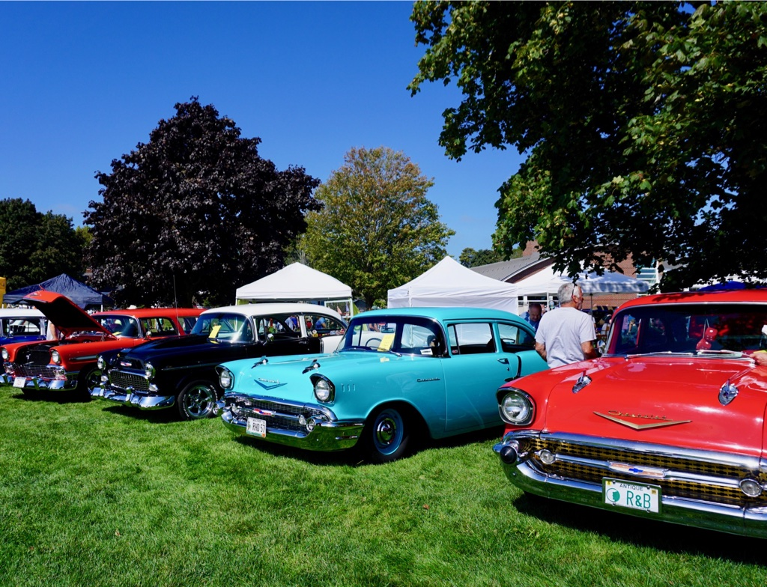](https://www.google.com/url?sa=i&url=https%3A%2F%2Foldorchardbeachmaine.com%2Fupcoming%2Fannual-car-show%2F&psig=AOvVaw3a8-XKxZJc-CB-I1vOgRYm&ust=1581712201824000&source=images&cd=vfe&ved=0CAIQjRxqFwoTCNCl3KGvz-cCFQAAAAAdAAAAABAp)

